##### ACADEMIC BOOK STORE WEBSITE

##### A PROJECT REPORT

###### ***Submitted by***

**Disha Yogesh Supekar (202101103154)**

**Vedshree Rajesh Kulkarni (202101103149)**

***For the subject WT-I Lab***

***of***

##### Second Year

**IN**

**COMPUTER SCIENCE & ENGINEERING**

Guided by

Prof.Sanket Milke (Assistant Professor, CSE, JNEC)



Computer Science and Engineering

**MGM’s Jawaharlal Nehru Engineering College, Ch. Sambhajinagar**

YEAR 2022- 2023

**CERTIFICATE**

This is to certify that the project report

**“ACADEMIC BOOK STORE WEBSITE ”**

Submitted by

**DISHA YOGESH SUPEKAR 202101103154**

**VEDSHREE RAJESH KULKARNI 202101103149**

is a bonafide work carried out by them under the supervision of Prof.Sanket Milke and it is approved for the subject WT-I Lab in academic year 2022-2023 Part-II Semester IV at JNEC, MGM University, Ch. Sambhajinagar.

Date:

Prof.Sanket Milke Dr. Vijaya B. Musande

GuideHead of Department

**Dept. of Computer Sci. & Engineering Dept. of Computer Sci. & Engineering**

Dr. H. H. Shinde

**Principal**

MGM’s Jawaharlal Nehru Engineering College, Ch. Sambhajinagar

**CONTENTS**

|  |  |  |
| --- | --- | --- |
| **SR.NO** | **TITLE** | **PAGE NO.** |
| **1.** | **INTRODUCTION**   |  | | --- | | 1.1 Introduction | | 1.2 Necessity | | |  | | --- | | 4 | | 5 | |
| **2.** | **FUNCTIONAL MODEL AND DESCRIPTION** | 6 - 7 |
| **3.** | **SYSTEM DESIGN AND IMPLEMENTATION** | 8 - 10 |
| **4.** | **CONCLUSION** | 11 |
| **5.** | **REFERENCES** | 12 |

1. **INTRODUCTION**

**1.1 INTRODUCTION:**

The academic book store website is an e-commerce platform that specializes in selling books related to academic subjects such as science, engineering, history, and literature, among others. This website caters to students, professors, researchers, and anyone interested in learning or teaching about a particular field of study. Academic book store websites offer a vast collection of books and resources, including textbooks, research papers, journals, and other reference materials.

This website typically has features such as a search bar to find books based on keywords or categories, user accounts to manage orders and preferences, reviews and ratings to help customers make informed decisions, and a secure checkout process to protect sensitive information. The design of academic book store websites is typically clean, organized, and easy to navigate, with clear calls to action to encourage users to browse and purchase books. Some academic book store websites also offer additional features, such as e-books, audiobooks, and study aids, to enhance the learning experience.

The Academic book store website provides a convenient and accessible way for students, researchers, and academics to access a wide variety of books and resources related to their fields of study. They offer a range of features and functionalities to make the book buying process efficient, secure, and enjoyable.

**1.2 NECESSITY:**

An academic book store website is a necessary tool for several reasons:

1. Convenience: The academic book store website provides the convenience of online shopping, allowing customers to browse and purchase books from anywhere, at any time. This is particularly beneficial for students and researchers who may have limited time to visit a physical bookstore.

2. Wide Selection: Academic book store websites offer a wider selection of books than physical stores, providing access to a vast array of academic texts, research papers, and reference materials.

3. Accessibility: Online bookstores are accessible to people with disabilities, including those who are visually impaired, as many websites offer features such as screen readers and magnifiers.

4. Competitive pricing: Online bookstores often offer competitive pricing, discounts, and promotions that are not available in physical stores, making academic books more affordable for students and researchers.

5. User reviews and recommendations: Academic book store websites often include customer reviews and recommendations, which can be helpful in making informed decisions about which books to purchase.

6. E-books and digital resources: Many academic book store websites also offer e-books and digital resources, making it easier for customers to access texts and resources on their devices.

The website offers features and functionalities that are not available in physical stores, making the learning and research process more efficient and enjoyable.

**2. FUNCTIONAL MODEL AND DESCRIPTION**

|  |  |  |  |
| --- | --- | --- | --- |
| **SR NO.** | **Function ID** | **Name of function** | **Description** |
| 1. | F-1 | Login | It allows users to create an account or log in with existing credentials to access their order history, manage their account settings, and expedite the checkout process for future purchases. |
| 2. | F-2 | Register | It Allows users to create a new account by providing their personal information, which can be used to manage their orders, track their preferences, and access exclusive content or discounts. |
| 3. | F-3 | Shop | It allows users to select books from a wide variety to purchase and also it compares rates. |
| 4. | F-4 | Search | It allows users to find specific books or resources by entering titles in the search bar. It provides a quick and efficient way to navigate through the vast collection of books available on the website. |
| 5. | F-5 | Cart | It allows users to add books to a virtual cart for later purchase. It also enables users to modify the quantity or remove items from the cart before proceeding to the billing process. |
| 6. | F-6 | Orders | It allows customers to place and manage orders for books and resources. This function typically includes features such as order history, tracking, and payment processing. |
| 7. | F-7 | Bill | It is responsible for handling payment and transaction-related tasks, ensuring a secure and reliable checkout process for customers. It involves calculating the total cost of the purchase, verifying payment information, and generating invoices and receipts for the customer's records. |
| 8. | F-8 | Admin Panel | It provides access to the backend of the site, allowing administrators to manage content, users, and settings. It is a crucial tool for website management and maintenance. |

**3. SYSTEM DESIGN AND IMPLEMENTATION**

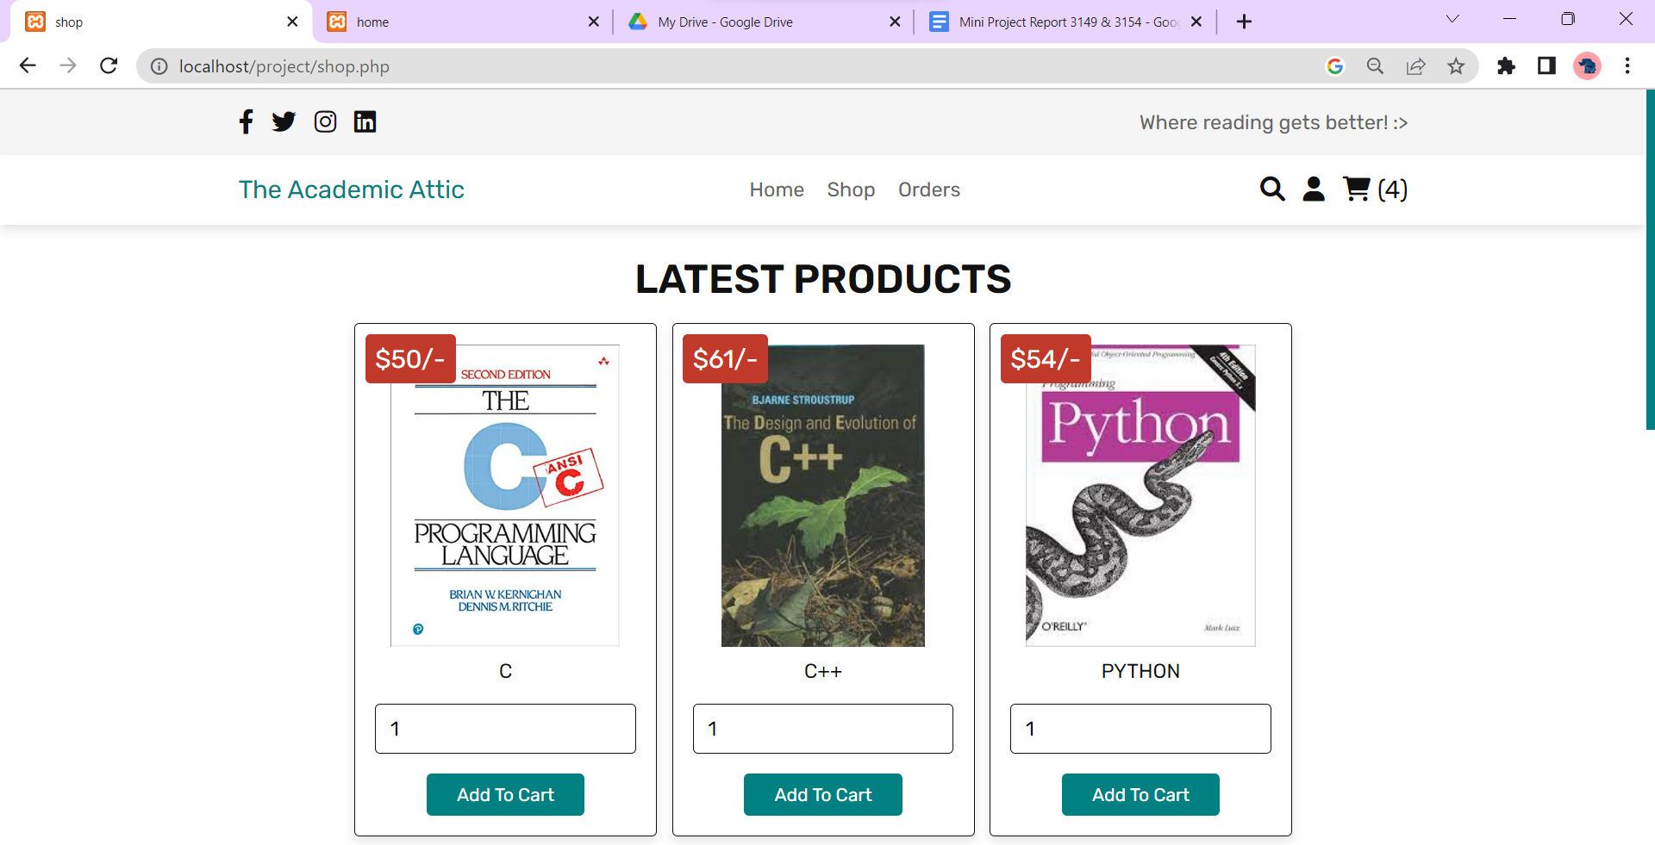

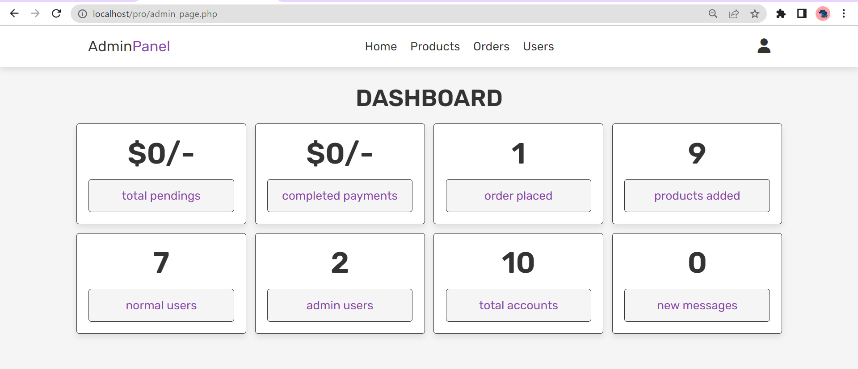

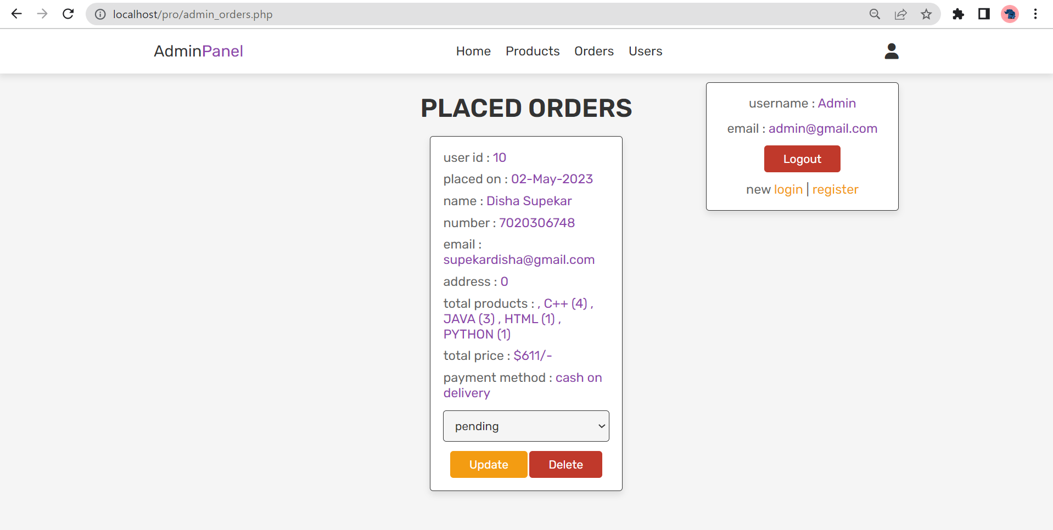

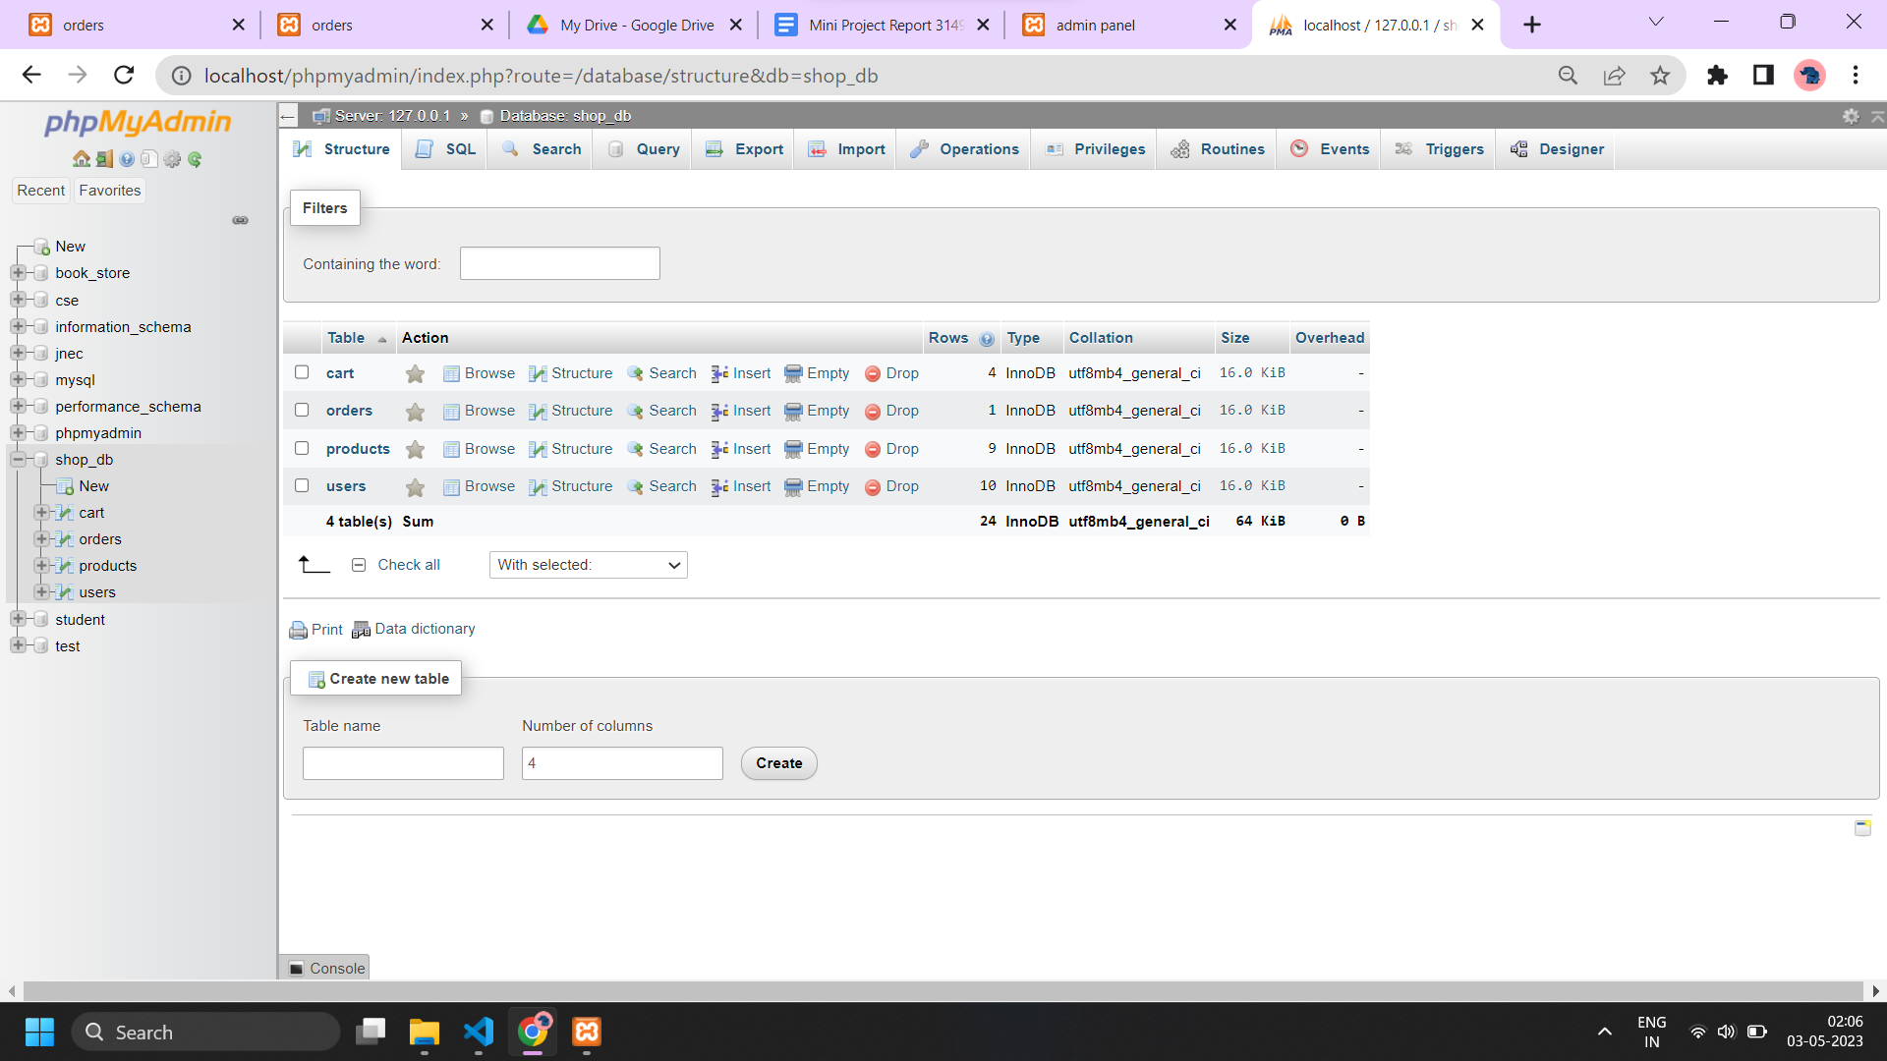

**USER HOMEPAGE:**

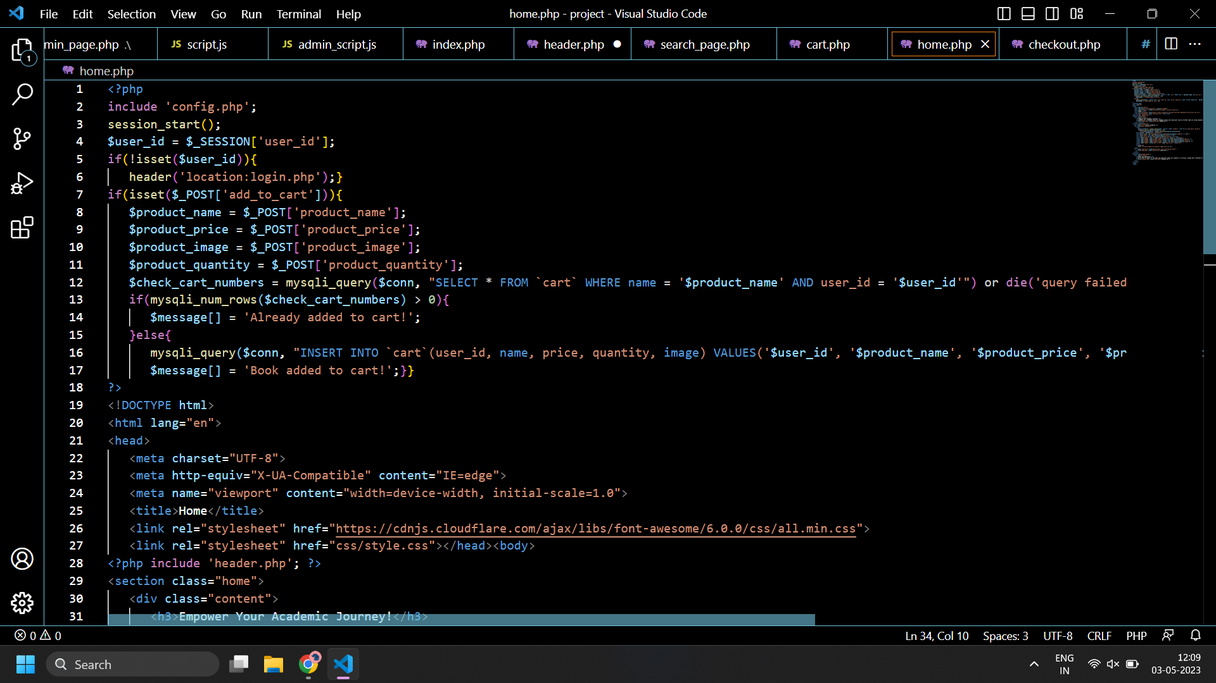

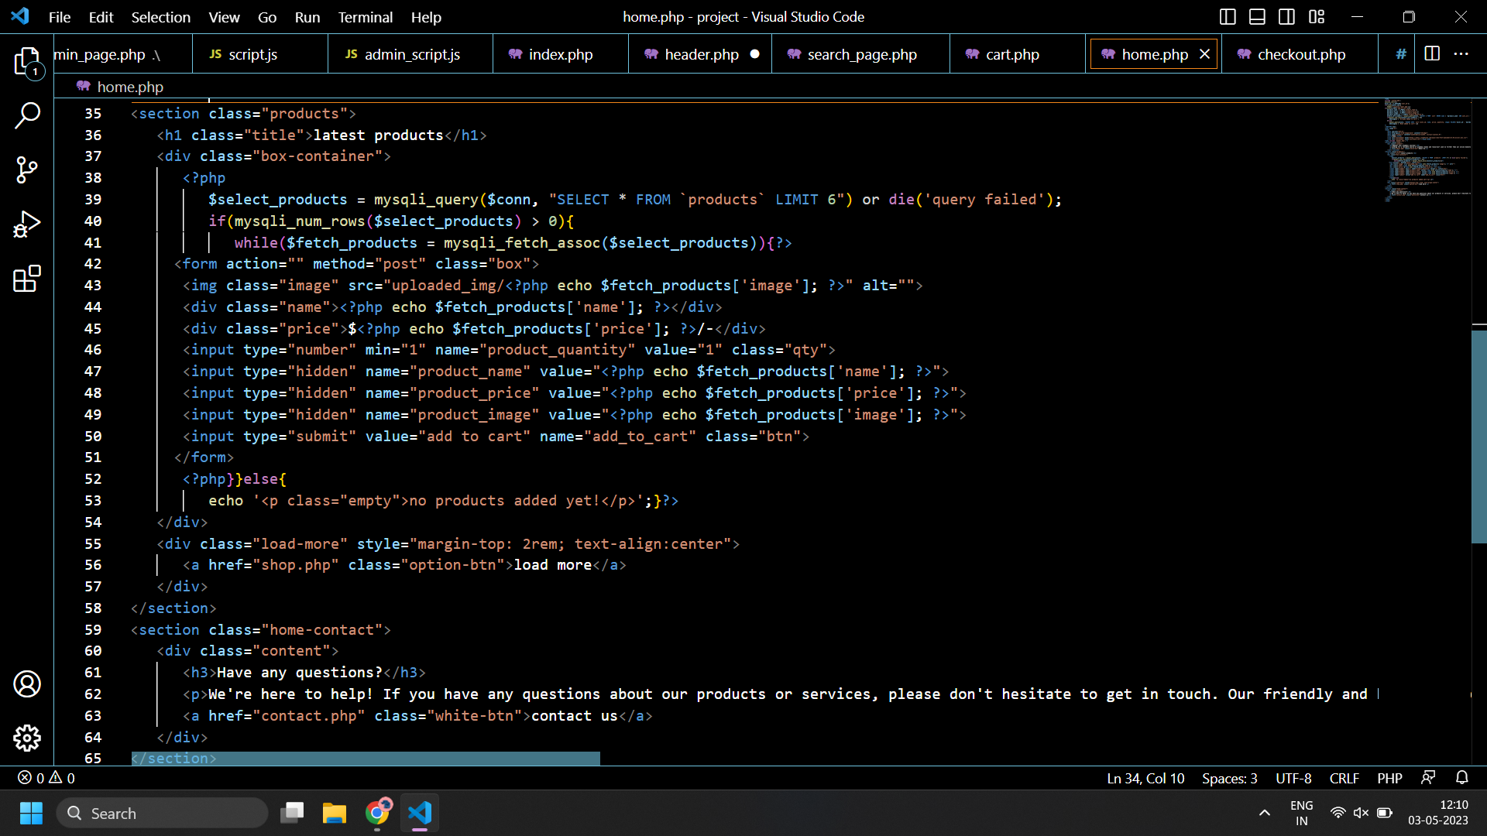

**4. CONCLUSION**

The academic book store website includes a wide range of academic books available, user-friendly navigation, and an efficient search function.

The academic book store website provides a convenient and efficient way for students and academics to access the books they need without the need to physically visit a bookstore.

It will provide an enjoyable and convenient shopping experience for its users to remain competitive in the academic book market.

The academic book store website is an essential resource for students and academics looking to purchase academic books conveniently and efficiently. It provides a wide range of knowledge , convenient search features , and the ability to access digital resources , making it a valuable tool for the academic community .

The website has the potential to be a valuable resource for students , educators and scholars. By providing a convenient platform for purchasing books. The website can help users save time and money.

Additionally , by offering a wide selection of materials and a user-friendly interface , the website can enhance the overall learning experience for students and educators alike.

**5. REFERENCES**

1.Complete Reference of HTML and CSS:

https://books.google.co.in/books?id=2w7_BOl1eL8C&q=complete+html+book+pdf&dq=complete+html+book+pdf&hl=en&newbks=1&newbks_redir=1&printsec=frontcover&sa=X&ved=2ahUKEwit-r7z3tb-AhVyTWwGHTZQAM8Q6AF6BAgJEAI

2. PHP and MYSQL:

https://books.google.co.in/books?id=jF48DwAAQBAJ&printsec=frontcover&dq=php+book&hl=en&newbks=1&newbks_redir=1&sa=X&ved=2ahUKEwj5v77C39b-AhWSa2wGHfszBjEQ6AF6BAgCEAI

3.Reference Video:

https://www.youtube.com/watch?v=6XmDdIRmg84

4.CSS information:

https://www.w3schools.com/css/

5.HTML Tags:

https://www.w3schools.com/tags/